Cities of the UK
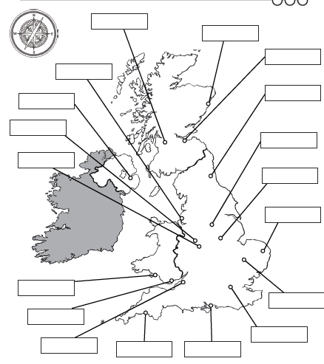
Use Google Mops to find these cities in the UK

