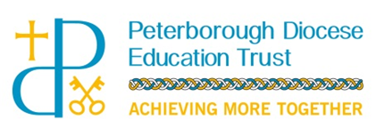

**Relationships, Sex and Health**

**Education Policy (RSHE)**

**CONTENTS**

Overview 3

Context and Guiding Principles 3

Aim 4

Statutory Requirements 4

Policy Development 5

Relationships Education 5

Health Education (Physical Health and Mental Well-being 7

Sex Education in Years 5 and 6 9

Links with the National Curriculum 11

Safeguarding 12

Monitoring and Evaluation 12

Review 12

APPENDICES

1. School / Academy Specific Information 13
2. Statutory Requirements for Relationships Education and Health Education 15
3. Trust Requirements for Specific Elements of RSHE 19
4. Parent / Carer Form: Request to be Excused from Sex Education (Right to Withdraw) 22
5. Church of England Education Office Charter 23

**Overview**

Our vision at Peterborough Diocese Education Trust (the Trust) is;

***‘Working together for every child to realise their God given potential to flourish.’***

Part of fulfilling this vision, is helping our pupils embrace the challenges of creating happy and successful lives. In order to do this, they ‘need knowledge that will enable them to make informed decisions about their wellbeing, health and relationships and to build their self-efficacy’[1]. Our intention is that our pupils will be able to put this knowledge into practice ‘as they develop the capacity to make sound decisions when facing risks, challenges and complex contexts’ and that that the subjects, as outlined in this policy, will ‘support them to develop resilience, to know how and when to ask for help, and to know where to access support’.

The Church of England has a charter for ‘*Faith Sensitive and Inclusive Relationships Education, Relationships and Sex Education and Health Education.’* We believe the Charter embraces the ethos of our Trust. A copy of the Charter is attached to this policy (Appendix 5) and we will be guided by the principles within it.

This policy is underpinned by the Trust’s commitment to inclusiveness and eliminating discrimination in accordance with the Equality Act 2010; advancing equality of opportunity between people who share a protected characteristic and people who do not share it, and to foster good relations across all characteristics.

**Context and Guiding Principles**

All of Relationships, Sex and Health Education is set in the context of a wider whole-school approach to supporting pupils to be safe, happy and prepared for life beyond school. It is complemented, and supported by, the Trust’s wider policies on behaviour, SEND, respect for equality and diversity, bullying and safeguarding. It sits within the context of a school / academy’s broader ethos and approach to developing pupils socially, morally, spiritually and culturally; and its pastoral care system.

Relationships and Health Education is compulsory in all primary schools / academies from September 2020. We choose to teach the compulsory content of Relationships and Health Education within a wider programme of Personal, Social, Health Education, integrated within a broad and balanced curriculum. This compulsory content is age appropriate and developmentally appropriate. It is taught sensitively and inclusively, with respect to the backgrounds and beliefs of pupils and parents / carers. The curriculum on Health Education complements, and is supported by, the school’s / academy’s wider education on healthy lifestyles through physical education, food technology, science, sport and extra-curricular activity.

Relationships and Health Education supports the wider work of our schools / academies in helping to foster pupil wellbeing and develop resilience and character that we know are fundamental to pupils being happy, successful and productive members of society. It complements the development of virtues such as kindness, integrity, generosity and honesty.

We are clear that parents and carers are the prime educators for pupils in relation to the above. We recognise that our schools / academies complement and reinforce this role.

**Aim**

The overriding aim of Relationships, Sex and Health Education, outlined in this policy, is to put in place the key building blocks for healthy, respectful relationships (focusing on family and friendships, in all contexts, including online) alongside an essential understanding of how to be healthy. Teaching about mental wellbeing is central to this. We know that children and young people are increasingly experiencing challenges, and that young people are at particular risk of feeling lonely. Teaching about mental wellbeing will give them the knowledge and capability to take care of themselves and know how to receive support if problems arise.

**Statutory Requirements**

The Relationships Education, Relationships and Sex Education and Health Education (England) Regulations 2019, made under sections 34 and 35 of the Children and Social Work Act 2017, make Relationships and Health Education compulsory for all pupils in primary schools.

This policy is based on the guidance *‘Relationships Education, Relationships and Sex Education (RSE) and Health Education: Statutory guidance for governing bodies, proprietors, headteachers, principals, senior leadership teams, teachers’* which contains information on what schools / academies **should** do and sets out the legal duties with which schools / academies **must** comply when teaching Relationships Education and Health Education.

This policy should be read in conjunction with the following policies and guidance:

* [Keeping Children Safe in Education (](https://www.gov.uk/government/publications/keeping-children-safe-in-education--2)statutory guidance);
* The Trust’s Safeguarding / Child Protection Policy;
* The Trust’s Equality Information and Objectives Statement;
* The Trust’s SEND Policy;
* The Behaviour Policy; and
* The Trust’s Prevention of Radicalisation and Extremism Policy.

Additional guidance can be found in the following documents:

* [Respectful School Communities: Self Review and Signposting Tool](http://educateagainsthate.com/download/36/) (a tool to support a whole school approach that promotes respect and discipline);
* [Behaviour and Discipline in Schools (](https://www.gov.uk/government/publications/behaviour-and-discipline-in-schools)advice for schools, including advice for appropriate behaviour between pupils);
* [Equality Act 2010 and schools;](https://www.gov.uk/government/publications/equality-act-2010-advice-for-schools)
* [SEND code of practice: 0 to 25 years](https://www.gov.uk/government/publications/send-code-of-practice-0-to-25) (statutory guidance);
* [Alternative Provision](https://www.gov.uk/government/publications/alternative-provision) (statutory guidance);
* [Mental Health and Behaviour in Schools (](https://www.gov.uk/government/publications/mental-health-and-behaviour-in-schools--2)advice for schools);
* [Preventing and Tackling Bullying (](https://www.gov.uk/government/publications/preventing-and-tackling-bullying)advice for schools, including advice on [cyberbullying)](https://assets.publishing.service.gov.uk/government/uploads/system/uploads/attachment_data/file/374850/Cyberbullying_Advice_for_Headteachers_and_School_Staff_121114.pdf);
* [Sexual violence and sexual harassment between children in schools](https://www.gov.uk/government/publications/sexual-violence-and-sexual-harassment-between-children-in-schools-and-colleges) (advice for schools);
* [The Equality and Human Rights Commission Advice and Guidance](https://www.equalityhumanrights.com/en/advice-and-guidance/) (provides advice on avoiding discrimination in a variety of educational contexts); and
* [Promoting Fundamental British Values as part of SMSC in schools](https://www.gov.uk/government/uploads/system/uploads/attachment_data/file/380595/SMSC_Guidance_Maintained_Schools.pdf) (guidance for maintained schools on promoting basic important British values as part of pupils’ spiritual, moral, social and cultural (SMSC) development).

**Policy Development**

This policy has been developed in consultation with staff, parents/carers, governors and the Trust Board. Policy development has been divided into two parts: whole policy and academy specific details and has involved the following steps:

Whole Policy Development:

1. An initial draft policy was prepared by the Trust’s Central Executive with reference to all relevant information including relevant national and local guidance.
2. The initial draft policy was submitted to a working group of Trust Headteachers for input and consultative purposes.
3. The revised draft policy was submitted to a Trust-wide parents’ reference group for consultation. All parents across the Trust were invited to take part.
4. The revised draft policy was submitted to the Ethos, Standards and Effectiveness committee (a committee of the Trust Board).
5. Ratification: following amendments, the final proposed policy was shared with, and ratified by, the Trust Board.

Academy Specific Policy Development:

1. An initial draft of Academy Specific details, including an overview of the programme of study to be taught, was prepared by individual academy Senior Leaders and Academy Governance Committee members (AGC).
2. The initial draft, including the overview of the programme of study, was submitted to staff at each academy for consultative purposes.
3. The revised draft was submitted to a parents’ reference group for consultation.
4. The final version of the Academy Specific details was appended to the Trust policy.

**Relationships Education**

**What is Relationships Education?**

The focus in primary school is teaching the fundamental building blocks and characteristics of positive relationships (which involves helping children understand relationships and behaviours that are not positive), with particular reference to friendships, family relationships and relationships with other children and with adults.

**The subject content**

Relationships Education starts with pupils being taught about:

* what a relationship is;
* what friendship is;
* what family means; and
* who the people are who can support them.

From the beginning of primary school, building on early education, pupils should be taught:

* how to take turns;
* how to treat each other with kindness, consideration and respect;
* the importance of honesty and truthfulness;
* permission seeking and giving; and
* the concept of personal privacy.

Establishing personal space and boundaries, showing respect and understanding the differences between appropriate and inappropriate / unsafe physical and other contact are the forerunners of teaching about consent, which takes place at secondary school.

Respect for others is taught in an age-appropriate way, for example, in terms of understanding one’s own and others’ boundaries in play and in negotiations about space and possessions.

Healthy friendships and relationships:

From the start of primary school, teachers talk explicitly about the features of healthy friendships, family relationships and other relationships which young children are likely to encounter. This enables pupils to form a strong, early understanding of the features of relationships that are likely to lead to happiness and security. This will also help them to recognise any less positive relationships when they encounter them.

Relationships – online:

The principles of positive relationships also apply online especially as many children in primary school will already be using the internet. When teaching relationships content, teachers will address online safety and appropriate behaviour in a way that is relevant to pupils’ lives. Teachers include content on how information and data is shared and used, for example, sharing pictures; understanding that many websites are businesses and hence, may use information provided by users in ways they might not expect.

Families:

Teaching about families requires sensitive and well-judged teaching. Families of many forms provide a nurturing environment for children. (Families can include for example, single parent families, LGBT parents, families headed by grandparents, adoptive parents, foster parents / carers amongst other structures.) Care is taken to ensure that there is no stigmatisation of children based on their home circumstances.

Development of personal virtues:

A growing ability to form strong and positive relationships with others depends on the deliberate development of positive personal virtues. Encouraging the development and practice of resilience, for example, helps pupils to believe they can achieve, persevere with tasks, work towards long-term rewards and continue despite setbacks. Alongside understanding the importance of self-respect and self-worth, pupils should develop personal virtues including honesty, integrity, courage, humility, kindness, generosity, trustworthiness and a sense of justice.

Positive mental and emotional wellbeing:

Relationships Education also creates an opportunity to enable pupils to be taught about positive emotional and mental wellbeing, including how friendships can support mental wellbeing.

Recognising abuse and boundaries:

Through Relationships Education, we teach pupils the knowledge they need to recognise and to report abuse, including emotional, physical and sexual abuse. This is delivered by focusing on boundaries and privacy, ensuring pupils understand that they have rights over their own bodies. This also includes understanding boundaries in friendships with peers, in families and with others, in all contexts, including online. Pupils are taught to know how to report concerns and seek advice when they suspect or know that something is wrong. At all stages, teaching pupils about making sensible decisions to stay safe (including online) is balanced with the fact that it is never the fault of a child who is abused and why victim blaming is always wrong.

See Appendix 2 for the statutory End of Primary School Expectations and Appendix 3 for the Trust’s Expectations regarding sensitive aspects.

## **How Relationships Education is taught and who is responsible for teaching it**

Effective teaching ensures that core knowledge is broken down into units of manageable size and communicated clearly to pupils, in a carefully sequenced way, within a planned programme of lessons. Teaching includes sufficient well-chosen opportunities and contexts for pupils to embed new knowledge so that it can be used confidently in real life situations.

Details of how individual schools / academies teach Relationships Education, and those responsible for the teaching, are set out in Appendix 1.

**Health Education (Physical Health and Mental Well-being)**

In addition to the content above, we also teach Health Education, both physical health (including puberty) and mental well-being. The national curriculum for Science also includes subject content in related areas, such as the main external body parts, the human body as it grows from birth to old age (including puberty) and reproduction in some plants and animals.

**What is Health Education?**

The aim of teaching pupils about physical health and mental wellbeing is:

* to give them the information that they need to make good decisions about their own health and wellbeing;
* to enable them to recognise what is normal and what is an issue in themselves and others; and
* when issues arise, to know how to seek support as early as possible from appropriate sources.

Physical health and mental wellbeing are interlinked, and it is important that our pupils understand that good physical health contributes to good mental wellbeing, and vice versa. It is important for schools / academies to promote pupils’ self-control and ability to self-regulate, and strategies for doing so. This will enable them to become confident in their ability to achieve well and persevere, even when they encounter setbacks or when their goals are distant, and to respond calmly and rationally to setbacks and challenges. This integrated, whole-school / academy approach to the teaching and promotion of health and wellbeing should have a positive impact on behaviour and attainment.

Our effective, quality teaching aims to reduce stigma attached to health issues, in particular those to do with mental wellbeing. We engender an atmosphere that encourages openness. This means that our pupils feel they can check their understanding and seek any necessary help and advice as they gain knowledge about how to promote good health and wellbeing.

We focus on teaching the characteristics of good physical health and mental wellbeing. Teachers are clear that mental wellbeing is a normal part of daily life, in the same way as physical health.

**The Subject Content**

Health Education starts with pupils being taught about the benefits and importance of:

* daily exercise;
* good nutrition; and
* sufficient sleep.

It gives pupils the language and knowledge to understand the normal range of emotions that everyone experiences. This enables pupils to articulate how they are feeling, develop the language to talk about their bodies, health and emotions and judge whether what they are feeling and how they are behaving is appropriate and proportionate for the situations that they experience.

Teachers go on to talk about the steps pupils can take to protect and support their own and others’ health and wellbeing, including:

* simple self-care techniques;
* personal hygiene;
* prevention of health and wellbeing problems; and
* basic first aid.

Emphasis is given to the positive two-way relationship between good physical health and good mental wellbeing, and the benefits to mental wellbeing of physical exercise and time spent outdoors.

Pupils are also taught the benefits of hobbies, interests and participation in their own communities. This teaching makes clear that people are social beings and that spending time with others, taking opportunities to consider the needs of others and practising service to others, including in organised and structured activities and groups (for example the scouts or girl guide movements), are beneficial for health and wellbeing.

Pupils are taught about the benefits of rationing time spent online and the risks of excessive use of electronic devices. In Key Stage 2, pupils are taught why social media, computer games and online gaming have age restrictions and our aim is that they should be equipped to manage common difficulties encountered online.

A firm foundation in the benefits and characteristics of good health and wellbeing will enable teachers to talk about isolation, loneliness, unhappiness, bullying and the negative impact of poor health and wellbeing.

Puberty is covered in Health Education for Years 5 and 6. This ensures male and female pupils are prepared for changes they and their peers will experience. The onset of menstruation can be confusing or even alarming for girls if they are not prepared. Hence, pupils are taught key facts about the menstrual cycle. (Adequate and sensitive arrangements are also put in place to help girls prepare for, and manage, menstruation including requests for menstrual products).

See Appendix 2 for the statutory End of Primary School Expectations and Appendix 3 for the Trust’s Expectations regarding sensitive aspects.

**How Health Education is taught and who is responsible for teaching it**

Details of how individual schools / academies will teach Health Education, and those responsible for the teaching, are set out in Appendix 1.

## **Sex Education in Years 5 and 6**

Whilst Relationships and Health Education are compulsory in all primary schools, Sex Education is not. However, it is important that the transition phase before moving to secondary school supports pupils’ ongoing emotional and physical development effectively. In line with DfE recommendations, therefore, our schools / academies incorporate a sex education programme to meet the needs of their pupils, tailored to the age and the physical and emotional maturity of their pupils and that has regard to their religious background. This ensures that both boys and girls are prepared for the changes that adolescence brings. Building on the knowledge of the human life cycle set out in the national curriculum for Science, pupils are taught how a baby is conceived and born.

Individual schools / academies ensure that their teaching and materials are appropriate, having regard to the age and religious backgrounds of their pupils. Individual schools / academies also take into account the significance of other factors, such as any special educational needs or disabilities of their pupils.

Details of the Trust’s requirements for Sex Education are set out in Appendix 3.

As well as consulting parents / carers more generally about the school’s / academy’s overall policy, our schools / academies consult parents / carers prior to the teaching of Sex Education about the detailed content of what is to be taught. This process will include offering parents an opportunity to digest the materials / resources that will be used when teaching Sex Education. It should also include signposting further resources to support them in talking to their children about Sex Education and how to link this with what is being taught in school / the academy.

**Right to be Excused from Sex Education (Right to Withdraw)**

Primary schools / academies that choose to teach Sex Education must allow parents / carers a right to request that their child is withdrawn from this teaching. Before granting any such request the headteacher will discuss the request with parents / carers and clarify the nature and purpose of the curriculum. The headteacher will also discuss with parents / carers the benefits of receiving this important education and any detrimental effects that withdrawal might have on the child. This could include any social and emotional effects of being excluded, as well as the likelihood of the child hearing their peers’ version of what was said in the classes, rather than what was directly said by the teacher.

Schools / academies will also take into account the significance of other factors, such as any special educational needs or disabilities of their pupils and will discuss these factors with the parents/carers.

Once the above discussions have taken place the school / academy should respect the parents’ / carers’ request to withdraw the child. Requests for withdrawal should be put in writing using the form found in Appendix 4 of this policy and addressed to the Headteacher / Head of School. Alternative work will be given to pupils who are withdrawn from Sex Education.

**W****orking with External Agencies**

Working with external organisations can enhance delivery of these subjects, bringing in specialist knowledge and different ways of engaging with young people. As with any visitor, schools / academies are responsible for ensuring that they check the visitor or visiting organisation’s credentials. Schools / academies should also ensure that the teaching delivered by the visitor fits with their planned programme and their published policy. It is important that schools / academies discuss the detail of how the visitor will deliver their sessions and ensure that the content is age-appropriate and accessible for the pupils. Schools / academies should ask to see the materials visitors will use as well as a lesson plan in advance, so that they can ensure it meets the full range of pupils’ needs (e.g. special educational needs).

It is important to agree how confidentiality will work in any lesson and that the visitor understands how safeguarding concerns should be dealt with in line with school / academy policy (see Safeguarding section below.)

Use of visitors should be to enhance teaching by an appropriate member of the teaching staff, rather than as a replacement for teaching by those staff.

**Managing Difficult Questions**

Primary-age pupils will often ask their teachers or other adults questions pertaining to sex or sexuality which go beyond what is set out for Relationships and Health Education and / or Sex Education. Given ease of access to the internet, children whose questions go unanswered may turn to inappropriate sources of information. Teachers should use a variety of strategies to provide opportunities for children to ask questions e.g. the use of a question box. However, questions should not be posed anonymously so that any safeguarding issues that arise can be dealt with effectively, in liaison with the DSL.

Children of the same age may be developmentally at different stages, leading to differing types of questions or behaviours. Teaching methods should take account of these differences (including specific special educational needs or disabilities) and consider the potential for discussion on an individual basis (with two adults present) or in small groups. Schools / academies will consider what is appropriate and inappropriate in a whole-class setting; it may be that some questions are better not dealt with in front of a whole class. Teachers should only answer questions that are within the year group’s Sex Education curriculum. Children should be told to ask their parents if questions go beyond the Sex Education curriculum offered at the school appropriate to their year group.

Details of how individual schools / academies handle such questions are set out in Appendix 1.

**How delivery of the content of RSHE is made accessible to all pupils, including those with SEND**

We recognise the significance of other factors, such as any special educational needs or disabilities of our pupils when teaching these subjects and our teaching methods take account of these differences. High quality teaching that is differentiated and personalised will be the starting point to ensure accessibility.

**Links with the National Curriculum:**

Our schools / academies work hard to ensure that the RSHE programme of study complements, and does not duplicate, content covered in the national curriculum subjects of Science, Computing and PE.

At Key Stages 1 and 2, the national curriculum for Science includes teaching about the main external parts of the body and changes to the human body as it grows from birth to old age, including puberty.

The national curriculum for Computing aims to ensure that all pupils can understand and apply the fundamental principles and concepts of computer science, including logic, algorithms and data representation. It also covers e-safety, with progression in the content to reflect the different and escalating risks that young people face as they get older. This includes how to use technology safely, responsibly, respectfully and securely, how to keep personal information private and where to go for help and support.

The national curriculum for PE aims to ensure that pupils develop competence to excel in a broad range of physical activities, are physically active for sustained periods of time, engage in competitive sport and activities and lead healthy, active lives.

**Safeguarding**

At the heart of Relationships, Sex and Health Education is a focus on keeping children safe and we recognise, as a Trust, our important role in preventative education. In line with Keeping Children Safe in Education (KCSIE) and the Trust’s Safeguarding / Child Protection Policy, we teach our pupils about safeguarding, including how to stay safe online, as part of providing a broad and balanced curriculum.

We also recognise that good practice allows pupils an open forum to discuss potentially sensitive issues. Such discussions can lead to increased reporting of safeguarding concerns and, therefore, we make our pupils aware of how to raise their concerns and how these will be handled. This includes processes for when they have a concern about a friend or peer.

All staff know what to do if a pupil tells them that they are being abused or neglected or are witnessing abuse, and how to manage the requirement to maintain an appropriate level of confidentiality. Schools / academies will ensure that pupils understand how confidentiality will be handled in a lesson and what might happen if they choose to raise a concern.

If any school / academy within the Trust invites external agencies in to support delivery of Relationships, Sex and Health Education, they must agree in advance of the session how a safeguarding concern should be dealt with by the external visitor – *see above*.

**Monitoring and Evaluation**

The delivery of Relationships, Sex and Health Education is monitored by the Headteacher / Head of School. The Headteacher / Head of School is responsible for ensuring that it is taught consistently across the school / academy in line with this policy, and for managing requests to withdraw pupils from Sex Education.

Monitoring and evaluation of the implementation of this policy in each individual school / academy is the responsibility of the Academy Governance Committee.

**Approval and Review**

Appendix 1 of this policy, where individual school / academy specific information is contained, is approved by the school’s / academy’s Academy Governance Committee. The full policy is approved by the Trust’s Board of Directors and reviewed every three years.

**Appendix 1**

**School / Academy Specific Information**

**Name of School / Academy: Kislingbury CE Primary School**

**Vision:** To ensure we give all our children the opportunity, support, guidance and care to reach their potential, academically, socially, emotionally and spiritually within a supportive Christian Family and through our shared Christian values of Hope, Forgiveness, Respect, Courage, Wisdom, Trust, Creativity and Kindness and with an overarching sense of love.

*‘Love is patient, love is kind, it does not envy it does not boast, it does not keep a record of wrongs, it rejoices in the truth. It always protects, always trusts, always hopes, and always perseveres.’*

*Corinthians 13*

**Policy Development**

Our policy was developed through engagement and input from volunteer parents from across all year groups at the school together with the subject lead, Headteacher and a staff governor.

For a full breakdown of the structure and map of how we teach this curriculum is attached as appendix 6.

**Relationships Education**

**Subject content**

In addition to what is set out in the policy and appendices, our Relationships Education ensures we focus on personal safety considering harassment and abuse from both sides, being proactive in terms of developing each child’s awareness of their own safety and that of others, including personal space and consent. We also ensure all our children have an adult in the school who they feel they can talk to if they are concerned in addition to a ‘worry Monster’ in each class. An overall breakdown of the aspects covered in our scheme is attached.

Our Relationships Education focuses on teaching the fundamental building blocks and characteristics of positive relationships including:

* + Families and close positive relationships
  + Friendships
  + Managing hurtful behaviour and bullying
  + Safe relationships
  + Respecting self and others

For our Relationships Education we follow a relevant programme of study outlined in the PSHE Association Programme of Study for PSHE Education.

**How we teach Relationships Education in our school / academy and who is responsible for teaching it**

Each class teacher will teach specific aspects of RSHE in dedicated lessons in addition to covering aspects across the curriculum in subjects such as science and P.E.

**Health Education**

Both physical and mental health is such an important aspect of every child’s development, in addition to the work with in our scheme on mental health and well being we also teach the children about healthy living through work on diet, exercise and hygiene. The school employs a family support worker who is also the mental health lead. We also have a number of whole school interventions such as free fruit snack each day for every child and the ‘treat Friday’ initiative.

**Subject content**

Health Education is organised in the following themes:

* + Healthy Lifestyles (physical wellbeing)
  + Mental Health
  + Ourselves, growing and changing
  + Keeping safe
  + Drugs, alcohol and tobacco

**How we teach Health Education in our school / academy and who is responsible for teaching it**

Health education is taught by the class teachers through the RHSE scheme but also through other areas of the curriculum such as P.E. Science and D.T.

**Sex Education**

**Subject content**

Children will be taught about the processes of reproduction and birth as part of the human life cycle and how babies are conceived, born and need to be cared for. We will also work with the children in gender specific sessions on consent, appropriateness of actions and personal space as well as what to do if they are feeling harassed, upset or just uncomfortable with the words or action of another child or adult.

**How we teach Sex Education in our school / academy and who is responsible for teaching it**

Sex education is taught by our staff with the help, when available of the School Nursing Team.

**Managing difficult questions**

If a pupil asks a question outside the scope of this policy, teachers will respond in an appropriate manner, using their professional judgement, so pupils are fully informed. If a question is deemed inappropriate for the age of the pupil, they will explain that their question will be answered by a responsible adult when they are older or they will be advised to ask a responsible adult at home. In this case parents/ carers will be contacted and informed. We consider which questions are appropriate and inappropriate to answer in a whole-class setting. If we consider a question needs to be answered solely for the child that has asked this, we ensure two adults are involved in the explanation. The school has a family support worker who is available to liaise with children and families if they have got aspects they wish to discuss further but feel the school’s input would help.

**Appendix 2**

**Statutory Requirements for Relationships Education and Health Education**

**Relationships Education**

**By the end of Year 6:**

|  |  |
| --- | --- |
| **Families and people who care for me** | Pupils should know   * that families are important for children growing up because they can give love, security and stability. * the characteristics of healthy family life, commitment to each other, including in times of difficulty, protection and care for children and other family members, the importance of spending time together and sharing each other’s lives. * that others’ families, either in school or in the wider world, sometimes look different from their family, but that they should respect those differences and know that other children’s families are also characterised by love and care. * that stable, caring relationships, which may be of different types, are at the heart of happy families, and are important for children’s security as they grow up. * that marriage[2] represents a formal and legally recognised commitment of two people to each other which is intended to be lifelong. * how to recognise if family relationships are making them feel unhappy or unsafe, and how to seek help or advice from others if needed. |
| **Caring friendships** | Pupils should know   * how important friendships are in making us feel happy and secure, and how people choose and make friends. * the characteristics of friendships, including mutual respect, truthfulness, trustworthiness, loyalty, kindness, generosity, trust, sharing interests and experiences and support with problems and difficulties. * that healthy friendships are positive and welcoming towards others, and do not make others feel lonely or excluded. * that most friendships have ups and downs, and that these can often be worked through so that the friendship is repaired or even strengthened, and that resorting to violence is never right. * how to recognise who to trust and who not to trust, how to judge when a friendship is making them feel unhappy or uncomfortable, managing conflict, how to manage these situations and how to seek help or advice from others, if needed. |
| **Respectful relationships** | Pupils should know   * the importance of respecting others, even when they are very different from them (for example, physically, in character, personality or backgrounds), or make different choices or have different preferences or beliefs. * practical steps they can take in a range of different contexts to improve or support respectful relationships. * the conventions of courtesy and manners. * the importance of self-respect and how this links to their own happiness. * that in school and in wider society they can expect to be treated with respect by others, and that in turn they should show due respect to others, including those in positions of authority. * about different types of bullying (including cyberbullying), the impact of bullying, responsibilities of bystanders (primarily reporting bullying to an adult) and how to get help. * what a stereotype is, and how stereotypes can be unfair, negative or destructive. * the importance of permission-seeking and giving in relationships with friends, peers and adults. |
| **Online relationships** | Pupils should know   * that people sometimes behave differently online, including by pretending to be someone they are not. * that the same principles apply to online relationships as to face-to-face relationships, including the importance of respect for others online including when we are anonymous. * the rules and principles for keeping safe online, how to recognise risks, harmful content and contact, and how to report them. * how to critically consider their online friendships and sources of information including awareness of the risks associated with people they have never met. * how information and data is shared and used online. |
| **Being safe** | Pupils should know   * what sorts of boundaries are appropriate in friendships with peers and others (including in a digital context). * about the concept of privacy and the implications of it for both children and adults; including that it is not always right to keep secrets if they relate to being safe. * that each person’s body belongs to them, and the differences between appropriate and inappropriate or unsafe physical, and other, contact. * how to respond safely and appropriately to adults they may encounter (in all contexts, including online) whom they do not know. * how to recognise and report feelings of being unsafe or feeling bad about any adult. * how to ask for advice or help for themselves or others, and to keep trying until they are heard. * how to report concerns or abuse, and the vocabulary and confidence needed to do so. * where to get advice e.g. family, school and / or other sources. |

**Health Education (Physical Health and Mental Well-being)**

**By the end of Year 6:**

|  |  |
| --- | --- |
| **Mental wellbeing** | Pupils should know   * that mental wellbeing is a normal part of daily life, in the same way as physical health. * that there is a normal range of emotions (e.g. happiness, sadness, anger, fear, surprise, nervousness) and scale of emotions that all humans experience in relation to different experiences and situations. * how to recognise and talk about their emotions, including having a varied vocabulary of words to use when talking about their own and others’ feelings. * how to judge whether what they are feeling and how they are behaving is appropriate and proportionate. * the benefits of physical exercise, time outdoors, community participation, voluntary and service-based activity on mental wellbeing and happiness. * simple self-care techniques, including the importance of rest, time spent with friends and family and the benefits of hobbies and interests. * isolation and loneliness can affect children and that it is very important for children to discuss their feelings with an adult and seek support. * that bullying (including cyberbullying) has a negative and often lasting impact on mental wellbeing. * where and how to seek support (including recognising the triggers for seeking support), including whom in school they should speak to if they are worried about their own or someone else’s mental wellbeing or ability to control their emotions (including issues arising online). * it is common for people to experience mental ill health. For many people who do, the problems can be resolved if the right support is made available, especially if accessed early enough. |
| **Internet safety and harms** | Pupils should know   * that for most people the internet is an integral part of life and has many benefits. * about the benefits of rationing time spent online, the risks of excessive time spent on electronic devices and the impact of positive and negative content online on their own and others’ mental and physical wellbeing. * how to consider the effect of their online actions on others and know how to recognise and display respectful behaviour online and the importance of keeping personal information private. * why social media, some computer games and online gaming, for example, are age restricted. * that the internet can also be a negative place where online abuse, trolling, bullying and harassment can take place, which can have a negative impact on mental health. * how to be a discerning consumer of information online including understanding that information, including that from search engines, is ranked, selected and targeted. * where and how to report concerns and get support with issues online. |
| **Physical health and fitness** | Pupils should know   * the characteristics and mental and physical benefits of an active lifestyle. * the importance of building regular exercise into daily and weekly routines and how to achieve this; for example, walking or cycling to school, a daily active mile or other forms of regular, vigorous exercise. * the risks associated with an inactive lifestyle (including obesity). * how and when to seek support including which adults to speak to in school if they are worried about their health. | |
| **Healthy eating** | Pupils should know   * what constitutes a healthy diet (including understanding calories and other nutritional content). * the principles of planning and preparing a range of healthy meals. * the characteristics of a poor diet and risks associated with unhealthy eating (including, for example, obesity and tooth decay) and other behaviours (e.g. the impact of alcohol on diet or health). | |
| **Drugs, alcohol and tobacco** | Pupils should know   * the facts about legal and illegal harmful substances and associated risks, including smoking, alcohol use and drug-taking. | |
| **Health and prevention** | Pupils should know   * how to recognise early signs of physical illness, such as weight loss, or unexplained changes to the body. * about safe and unsafe exposure to the sun, and how to reduce the risk of sun damage, including skin cancer. * the importance of sufficient good quality sleep for good health and that a lack of sleep can affect weight, mood and ability to learn. * about dental health and the benefits of good oral hygiene and dental flossing, including regular check-ups at the dentist. * about personal hygiene and germs including bacteria, viruses, how they are spread and treated, and the importance of handwashing. * the facts and science relating to allergies, immunisation and vaccination. | |
| **Basic first aid** | Pupils should know:   * how to make a clear and efficient call to emergency services if necessary. * concepts of basic first-aid, for example dealing with common injuries, including head injuries. | |
| **Changing adolescent body** | Pupils should know:   * key facts about puberty and the changing adolescent body, particularly from age 9 through to age 11, including physical and emotional changes. * about menstrual wellbeing including the key facts about the menstrual cycle. | |

**Appendix 3**

**Trust Requirements for Specific Elements of RSHE**

The following outlines the Trust requirements for elements of Relationships, Sex and Health Education that may be particularly sensitive. These include the areas of:

* Families and Close Positive Relationships;
* Growing and Changing; and
* Sex Education.

The requirements below are based on the PSHE Association Programme of Study, 2020.

**Families and Close Positive Relationships**

**By the end of Year 2:**

|  |  |
| --- | --- |
| **Families and Close Positive Relationships** | Pupils will know:   * about the roles different people (e.g. acquaintances, friends and relatives) play in our lives. * how to identify the people who love and care for them and what they do to help them feel cared for. * about different types of families including those that may be different to their own. * how to identify common features of family life. * that it is important to tell someone (such as their teacher) if something about their family makes them unhappy or worried. |

**By the end of Year 6:**

|  |  |
| --- | --- |
| **Families and Close Positive Relationships** | Pupils will know:   * to recognise that there are different types of relationships (e.g. friendships, family relationships, romantic relationships, online relationships). * that people may be attracted to someone emotionally, romantically and sexually; that people may be attracted to someone of the same sex or different sex to them; that gender identity and sexual orientation are different. * about marriage and civil partnership as a legal declaration of commitment made by two adults who love and care for each other, which is intended to be lifelong. * that forcing anyone to marry against their will is a crime; that help and support is available to people who are worried about this for themselves or others. * that people who love and care for each other can be in a committed relationship (e.g. marriage), living together, but may also live apart. * that a feature of positive family life is caring relationships; about the different ways in which people care for one another. * to recognise and respect that there are different types of family structure (including single parents, same-sex parents, step-parents, blended families, foster parents); that families of all types can give family members love, security and stability. * to recognise other shared characteristics of healthy family life, including commitment, care, spending time together; being there for each other in times of difficulty. * how to recognise if family relationships are making them feel unhappy or unsafe, and how to seek help or advice. |

**Growing and Changing**

**By the end of Year 2:**

|  |  |
| --- | --- |
| **Growing and Changing** | Pupils should know:   * what makes them special. * the ways in which they are all unique. * how to identify what they are good at, what they like and dislike. * how to manage when finding things difficult. * the names of the main parts of the body including external genitalia (e.g. vulva, breasts, penis, testicles). * about growing and changing from young to old and how people’s needs change. * about preparing to move to a new class / year group. |

**By the end of Year 6:**

|  |  |
| --- | --- |
| **Growing and Changing 1** | Pupils should know:   * about personal identity; what contributes to who we are (e.g. ethnicity, family, gender, faith, culture, hobbies, likes / dislikes). * how to recognise their individuality and personal qualities. * how to identify personal strengths, skills, achievements and interests and how these contribute to a sense of self-worth. * how to manage setbacks / perceived failures, including how to re-frame unhelpful thinking. |
| **Growing and Changing 2** | Pupils should know:   * that for some people gender identity does not correspond with their biological sex. * the external genitalia and internal reproductive organs in males and females and how the process of puberty relates to human reproduction. * about the physical and emotional changes that happen when approaching and during puberty (including menstruation, key facts about the menstrual cycle and menstrual wellbeing, erections and wet dreams). * the following terminology related to the above: vulva, cervix, ovaries, uterus (womb), vagina, fallopian tubes, ovum, breasts, pubic hair, penis, testicles, sperm, semen, sperm duct, urethra. * about how hygiene routines change during the time of puberty, the importance of keeping clean and how to maintain personal hygiene. * about where to get more information, help and advice about growing and changing, especially about puberty. * about the new opportunities and responsibilities that increasing independence may bring. * strategies to manage transitions between classes and key stages. |

**Sex Education**

**By the end of Year 6**

|  |  |
| --- | --- |
| Sex Education  (Years 5 and 6) | Pupils should know:   * about the processes of reproduction and birth as part of the human life cycle. * how babies are conceived and born. * how babies need to be cared for. |

**Appendix 4**

**Parent / Carer Form: Request to be Excused from Sex Education (Right to Withdraw)**

| To be completed by parents / CARERS | | | |
| --- | --- | --- | --- |
| Name of child |  | Class |  |
| Name of parent / carer |  | Date |  |
| Reason for withdrawing from Sex Education within the Relationships, Sex and Health Education provision | | | |
|  | | | |
| Parent / carer signature |  | | |

| To be completed by the school / ACADEMY | |
| --- | --- |
| Agreed actions from discussion with parents / carers |  |
| Headteacher / Head of School signature |  |



**Appendix 5**

**A CHARTER FOR FAITH SENSITIVE AND INCLUSIVE RELATIONSHIPS EDUCATION, RELATIONSHIPS AND SEX EDUCATION (RSE) AND HEALTH EDUCATION (RSHE)1**

We seek to provide Relationships Education, Relationships and Sex Education (RSE) and Health Education (RSHE), which will enable all pupils to flourish.

**We commit:**

1. **To work in partnership with parents and carers**. This will involve dialogue with parents and carers through all stages of policy development as well as discussing the resources used to teach their children and how they can contribute at home. It must, however, be recognised that the law specifies that what is taught and how it is taught is ultimately a decision for the school.

2. **That RSHE will be delivered professionally and as an identifiable part of PSHE**. It will be led, resourced and reported to parents in the same way as any other subject. There will be a planned programme delivered in a carefully sequenced way. Staff will receive regular training in RSHE and PSHE. Any expert visitors or trainers invited into the school to enhance and supplement the programme will be expected to respect the schools published policy for RSHE.

3. **That RSHE will be delivered in a way that affords dignity and shows respect to all who make up our diverse community.** It will not discriminate against any of the protected characteristics in the Equality Act2 and will be sensitive to the faith and beliefs of those in the wider school community. RSHE will seek to explain fairly the tenets and varying interpretations of religious communities on matters of sex and relationships and teach these viewpoints with respect. It will value the importance of faithfulness as the underpinning and backdrop for relationships. It will encourage pupils to develop the skills needed to disagree without being disagreeable, to appreciate the lived experience of other people and to live well together.

4. **That RSHE will seek to build resilience in our pupils to help them form healthy relationships, to keep themselves safe and resist the harmful influence of pornography in all its forms**. It will give pupils opportunities to reflect on values and influences including their peers, the media, the internet, faith and culture that may have shaped their attitudes to gender, relationships and sex. It will promote the development of the wisdom and skills our pupils need to make their own informed decisions.

___________________________

1 RSHE is used to indicate either Relationships Education, Relationships and Sex Education and Health Education as determined by the school context since, after consultation with parents and carers primary schools may decide to include elements of sex education in their curriculum.

2 The protected characteristics are age, disability, gender reassignment, race, religion or belief, sex, sexual orientation, marriage and civil partnership and pregnancy and maternity.

5. **That RSHE will promote healthy resilient relationships set in the context of character and virtue development**. It will reflect the vision and associated values of the school, promote reverence for the gift of human sexuality and encourage relationships that are hopeful and aspirational. Based on the school’s values it will seek to develop character within a moral framework based on virtues such as honesty, integrity, self-control, courage, humility, kindness, forgiveness, generosity and a sense of justice but does not seek to teach only one moral position.

6. **That RSHE will be based on honest and medically accurate information from reliable sources of information, including about the law and legal rights**. It will distinguish between different types of knowledge and opinions so that pupils can learn about their bodies and sexual and reproductive health as appropriate to their age and maturity.

7. **To take a particular care to meet the individual needs of all pupils including those with special needs and disabilities.** It will ensure that lessons and any resources used will be accessible and sensitive to the learning needs of the individual child. We acknowledge the potential vulnerability of pupils who have special educational needs and disabilities (SEND) and recognise the possibilities and rights of SEND pupils to high quality Relationships and Sex Education.

8. **To seek pupils’ views about RSHE so that the teaching can be made relevant to their lives.** It will discuss real life issues relating to the age and stage of pupils, including friendships, families, faith, consent, relationship abuse, exploitation and safe relationships online. This will be carefully targeted and age appropriate based on a teacher judgment about pupil readiness for this information in consultation with parents and carers.

© The Church of England Education Office November 2019

**Appendix 6**

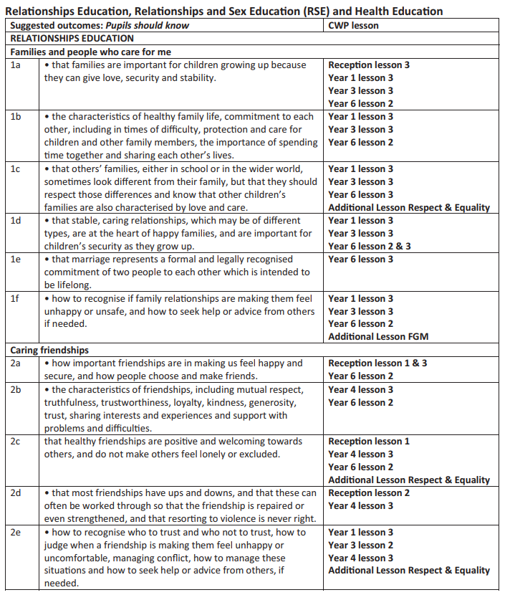

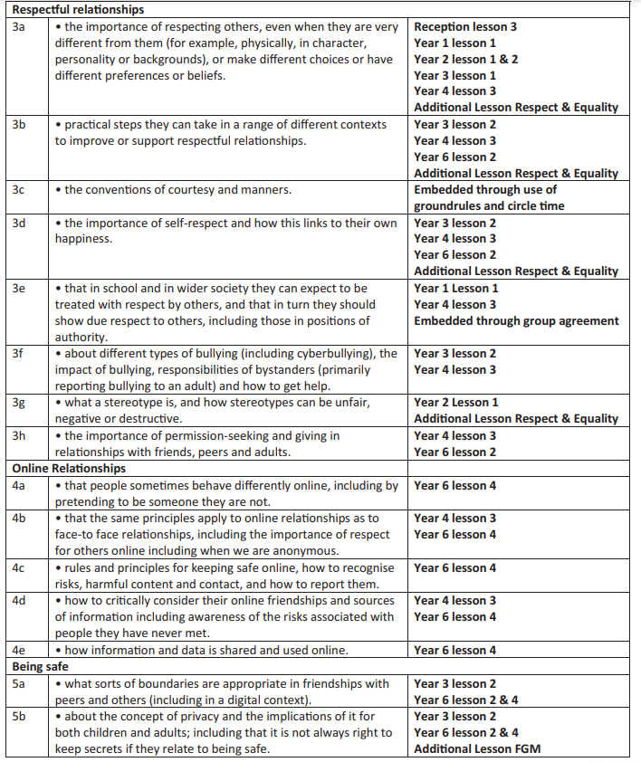

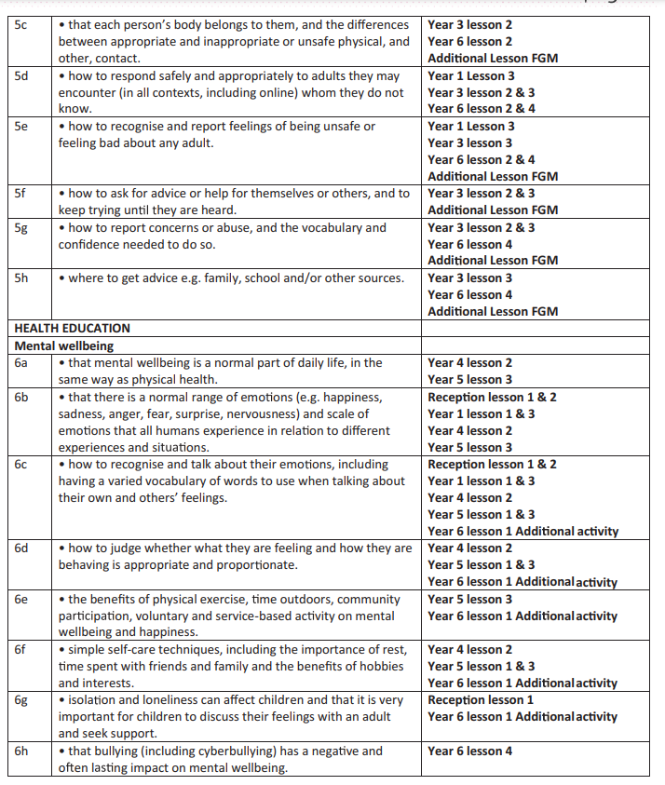

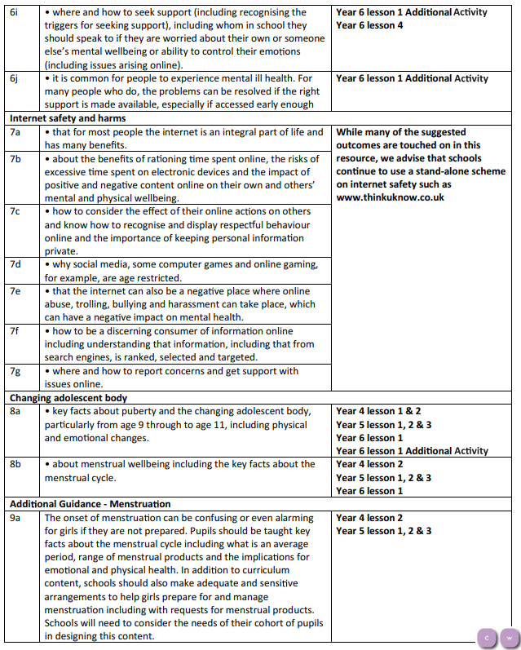

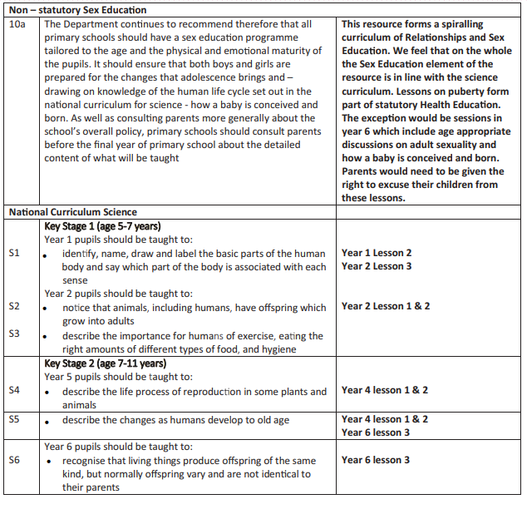

1. Relationships Education, Relationships and Sex Education (RSE) and Health Education: Statutory guidance for governing bodies, proprietors, head teachers, principals, senior leadership teams, teachers (DfE, 2019)
2. Marriage in England and Wales is available to both opposite sex and same sex couples. The Marriage (Same Sex Couples) Act 2013 extended marriage to same sex couples in England and Wales. The ceremony through which a couple get married may be civil or religious.