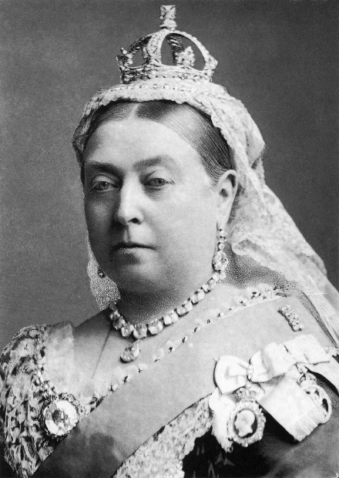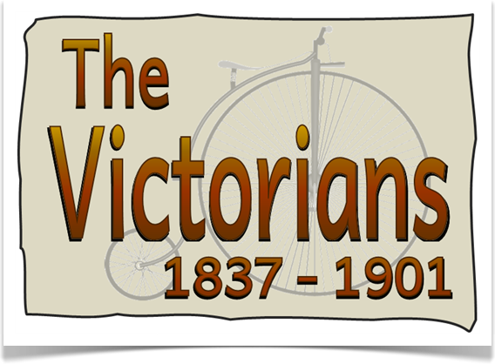 Rockingham Class Newsletter – Autumn 2017

Class Messages

**Children’s Interests**

Babies & Families

Homes & Dens

Being Teachers!!

We will also follow

the rest of the

school with

the topic:

Whose

Shoes?

Hard Times

Welcome back to school, after what I hope was an enjoyable break. The children have returned to school eager to learn about their new topic – Hard Times. As part of this topic, we will explore what it was really like living in Victorian times, particularly for children. This week, we have kick-started our topic learning with an art theme - creating our own Victorian streetscapes. Look out for our display of these in the corridor!

**Extra Home Learning Activity**

Children had to make their own entertainment in the Victorian times - there was no TV - so they used to put on puppet shows in homemade shoebox style theatres. Make your own stage and puppets and entertain the class – you could use characters or real people from Victorian times.

*Bring into school w/c 11th December.*

**If you have any questions or concerns then please do not hesitate to contact me. *Miss Holland***

**Key Class Dates**

-Tuesday 19th September: Class trip to the Black Country Museum. Reminder that we will return to school at approx.. 5pm.

- Reading open morning 8.45 – 10am

- Times Table tips. A half an hour workshop to provide some help with supporting the learning of times tables at home.

**Home Learning expectations**

Home learning will be sent out on a Wednesday and collected in on a Tuesday (as in previous years). Children will be expected to recite the sentence(s) of the week from memory, as well as completing a spelling test each Tuesday.

Reading is an integral part of your child’s homework, and it is essential that they read **aloud** to you **at least** three times per week. However, the more often your child reads, the better progress they will make. As well as your child reading to you, it is still important that you continue to read to your child in order to foster a true love of books.

**Key Literacy Focuses**

These are the key text types that we will be focusing on throughout the Autumn Term:

* Non-chronological report (Victorian schooling)
* Narrative (based around the novel Street Child)
* Biography (Queen Victoria)
* Explanation text (electricity)
* Narrative (based around A Christmas Carol)

**Key Maths Focuses**

The following maths focuses will take us up to Christmas:

- Place value

- Addition and subtraction

- Multiplication and division

- Perimeter

How can I help at home?

-Practise counting forwards and backwards in steps of 6, 7, 9, 25 and 1000 with your child.

-Count backwards through 0 to include negative numbers.

-Practise reading and writing numbers (4 digits for Year 4s and up to 7 digits for Year 5s).

-Quick addition and subtraction facts (these should be instant). Bonds up to and including 100.

-Instant recall of multiplication facts up to 12x12. These should be secure by the end of year 4.